BIOCHEMISTRY W3300 Fall 2016  
Problem Set 3 (16 pts)

Name: ________________________________________ Uni: ____________________________

For the following questions, answer them fully and show all work (if applicable). Use the blank space given appropriately.

**Question 1:** For this question, please do not assume general protonation/deprotonation rules of amino acids. (7 points total)

1. Draw the structure of the amino acid glutamate at physiological pH. (2 pts)
2. Calculate the precise overall charge of glutamate at pH 3.5. (5 pts)

**Question 2:** For this question, answer using the follow pentapeptide, shown at physiological pH: (9 points total)

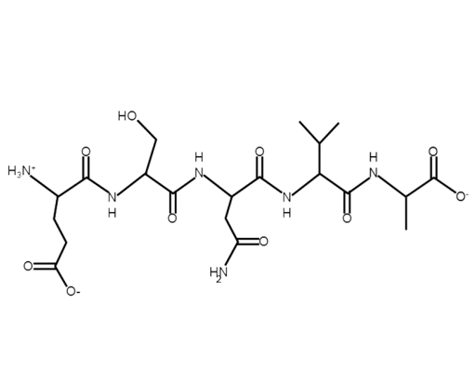

1. Give the 1-letter code of each amino acid in the sequence: (3 pts)
2. Calculate the precise overall charge of the peptide at pH 3.34. (6 pts)